project plan

Group 4: GHERLAN MIRELA-CRISTIANA, MORENC FELIX, MANOLOV MONI, JAGWANI YASH

TABLE OF CONTENTS

*PROJECT PLAN 2*

*MEMBERS OF THE PROJECT 2*

*CHAPTER 1: CLIENT & TEAM MEMBERS 4*

*• Client 4*

*•Team: 4*

*•Team name & logo: 4*

*CHAPTER 2 : CURRENT SITUATION 5*

*•Current situation: 5*

*•Problem description: 5*

*CHAPTER 3 : OUR GOAL 6*

*• Project goal: 6*

*• Deliverables: 6*

*• Non-deliverables: 6*

*• Constraints: 6*

*CHAPTER 4 : PLANNING 8*

*• Phasing: 8*

*WATERFALL TABLE 8*

# PROJECT PLAN

## MEMBERS OF THE PROJECT

|  |  |
| --- | --- |
| Data Member 1 | |
| Name | Mirela- Cristiana Gherlan |
| Student number | 3889254 |
| Project period | 1st Year, Software Engineering semester 2 |
| Role |  |
| Data Member 2 | |
| Name | Moni Manolov |
| Student number | 4003683 |
| Project period | 1st Year, Software Engineering semester 2 |
| Role |  |
| Data Member 3 | |
| Name | Yash Jagwani |
| Student number | 3857069 |
| Project period | 1st Year, Software Engineering semester 2 |
| Role |  |
| Data Member 4 | |
| Name | Felix Morenc |
| Student number | 3841855 |
| Project period | 1st Year, Software Engineering semester 2 |
| Role |  |
| Data Company | |
| Name company/institution | Jupiter-Media Bazaar BV |
| Address | Philipslaan 23, Eindhoven |
| Tutor | |
| Family name, initials | Schouwenaars, Basjan B.T.J.C. |
| Client | |
| Family name, initials | Zhao, Qin Q. |
| Project Plan | |
| Title | Media Bazaar Application |
| Date | February 2020 |

## CHAPTER 1: CLIENT & TEAM MEMBERS

### • Client

* **Who is your client?**

The company Media Bazaar.

* **How can you contact your client?**

We can contact our client via email or by phone.

* **Which company does your client represent?**

Their parent company, Jupiter.

### •Team:

* **Who represents your group?**

Our team is made up of 4 members : Felix, Moni, Mirela and Yash.

* **How can you contact this person?**

You can contact us via our emails.

* **Which team does this person represent?**

We are the CB06-Group 04 and we decided that all members should be involved in representing our team, because each of us contributes equally to the success of the team.

### •Team name & logo:

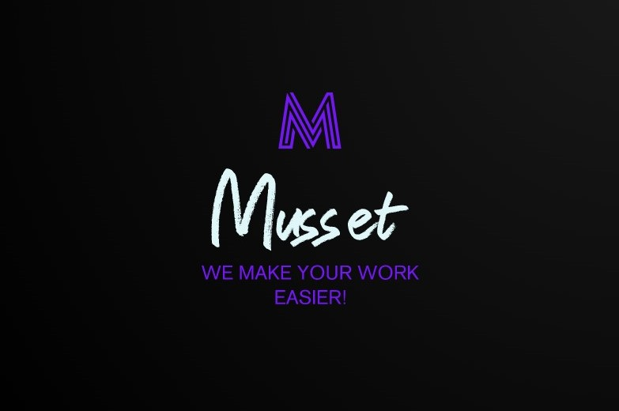

## CHAPTER 2 : CURRENT SITUATION

### •Current situation:

* **What is currently known (contextually) about factors that influence your project?**
* **E.g.: Are there competitors working on a similar solution? Is there an existing system that you build on? Etc.**

At this point in time, parent company Jupiter, is starting up a new store called Media Bazaar. We’ve been hired to implement a software solution for the company to use to foremost manage employees and stock. This means at this point in time there is no existing system that we will be building on, and we are also the only people working to develop the system for the company. In terms of other factors that will influence our project, time will be crucial to keep in mind and manage effectively as we have a pretty strict deadline to deliver

### •Problem description:

* **What problem does the client have which they want to be solved?**
* **The problem is never that the client does not have the solution you are working on.**
* **If you know your solution, think about what problem your solution can solve?**

The current problem that the client has which they want to be solved include keeping track of employees and products and also assigning work shifts to employees as well as the ability to view these work shifts per person but also for the entire store. Our solution definitely has the possibility to solve their problems.

## CHAPTER 3 : OUR GOAL

### • Project goal:

* **What does your project attempt to achieve?**
* **The problem describes lack of “something” (time, money, a clear overview, etc.) the goal describes the desired result.**
* **Your solution is not a desired result, it is but one means to realize this result!**

Our project attempts to achieve the solution to the specified problem by the company, but also to provide some additional features that can further enhance our solution and aid the company more. We hope to do this within the constraints put under us such as the time frame we have to create and deliver the project and also with the human resources that we currently have.

### • Deliverables:

* **What products are you going to deliver?**
* **Documentation that supports the process are not deliverables (not to be confused with non deliverables).**
* **You only say what you deliver, don’t describe your product(s) here.**

Our deliverables include most crucially of a software solution and a website, as of now.

### • Non-deliverables:

* **What are you not going to deliver?**
* **There are a lot of things you will not deliver, but what might your client expect?**
* **Were there requests by your client that you explicitly mentioned you will not deliver?**
* **Might your client have expectations based on your deliverables list?**

One of our non- deliverables consists of a UML diagram and Workflow diagram, which we will create to give us an idea of how to go about our project. The other documentation such as the URS, progress reports and test plans are also included as a part of our non-deliverables.

### • Constraints:

* **What are the project limits?**
* **In order to keep the project realistic, you can define a scope for the project.**
* **Limitations can be related to: time, money, quality, but are not restricted to these points.**
* **What programming language are you going to use? How much money will you have to spend on possible hardware purchases? What are important deadlines? Etc.**

Our goal is to make a product which is made using C#, HTML, CSS, MySQL, PHP and the other things that we will learn. Time is definitely a key limitation when it comes to working on this project. Every deadline is important and we’ll strive to submit the required documents or software ahead of time. In terms of money, there isn’t any hardware for us to buy or employees to pay so this isn’t in any way a limitation to our project

## CHAPTER 4 : PLANNING

### • Phasing:

**How do you plan to conduct your project?**

* **Phases: your project will have phases (timeframes) that conclude in project sub-deliverables.**
* **Milestones: Phases conclude with milestones, deadlines where you finished sub-deliverables that can be reviewed by your client. These moments can result in go/no-go decision.**
* **In the project plan you describe the planning towards your client (not your internal planning). So how many go/no-go decisions do you want?**

We plan to conduct our project following the waterfall model, starting with our analysis/project plan. In this phase we intend to set up our general requirements and intentions that we hope to achieve in this project. Once we have completed this phase, we will move on to the design phase, then the implementation phase, testing phase and lastly, deployment of the completed product. The milestones we have set out include the completion of each of the documents specified and having an interim/working version of our software and finally a fully functional software solution and completed report. We plan to have 4 to 6 meetings with the client per month to present our progress and get feedback on if they are satisfied with what we have done and also help improve our product.

## WATERFALL TABLE

|  |  |  |  |  |  |
| --- | --- | --- | --- | --- | --- |
| Week 1 | Week 2 | Week 3 | Week 4 | Week 5 | Week 6 |
| • Create a name and logo for your group  • Interview client  • Project plan | • Improve project plan based on feedback  • Create URS | • Improve URS based on feedback  • Implement software solution | • Implement software solution | • Implement software solution  • Test plan  • Send test plan and binaries to peers  • Test report | • Tag software as deliverable in GIT repository  • Present final version |

## Deadlines:

* **Week 1**- 14.02.2020
* **Week 2**- 21.02.2020
* **Week 3**- 06.03.2020
* **Week 4**- 13.03.2020
* **Week 5**- 20.03.2020
* **Week 6**- 27.03.2020